Week 5
Extra queries on employee database

1) select D.Dname,E.empname /*1*/
from dept D,employee E
where E.deptno=D.deptno;

Output
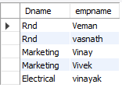

2)select E.empName /*2*/
from employee E
where E.empno not in (select a.empno from assigned_to a);

Output

3)select D.deptNo , max(E.sal) as maximum_salary,avg(E.sal) as average_salary /*3*/
from employee E,dept D
where E.deptNo=D.deptNo
group by D.deptNo;

Output
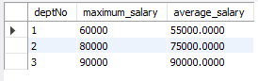

4) select E.empName , sum(i.incentive_amount) as Total_incentives /*4*/
from employee E , incentives i
where E.empNO=i.empNo
group by E.empno;
Output
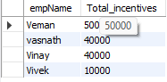

5) select E.empName , a.empNo,a.pno,p.Pname /*5*/
from employee E,projects P,assigned_to a
where E.empNo = a.empNo and p.pno=a.pno and p.pname='WEb development';

Output


6) select d.dName /*6*/
from dept D
where D.deptNo not in (select e.deptno from employee e);

Output
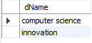
7)select M.empName as manager_name,count(e.empno) as Report_count /*7*/
from employee e , employee M
where e.mgr_no=M.empno
group by M.empName;

Output
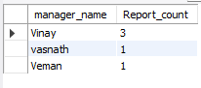
8) select e.empname,count(a.pno) as number_of_projects
from employee e, assigned_to a
where a.empno=e.empno
group by e.empname
having count(a.pno)>1;
Output


